Nuclear Engineering and Nonproliferation (NEN)
Safeguards Science and Technology (NEN-1)

Title: | Source Tracker Software Design
Number: NEN1-ST-SD |  |  | Revision: 3.1 | Page 1 of 30

Authority | Name | Title/Org | Signature | Date
Preparer/  Software Designer | Heather Nordquist | Project Manager/  NEN-1
SQA Reviewer | Cecilia Rivenburgh | HPC-1
Software Owner (SO) | Jon Bridgewater | NEN-1
Software Owner RLM (SO RLM) | Stacey Eaton | NEN-DO
Software User (SU) | David Miko | NEN-1
Software User RLM (SU RLM)/  Software Designer RLM (SD RLM) | Jon Bridgewater | Group Leader/  NEN-1

History of Revisions

Revision Number | Approval Date | Change Description
Revision 1.0 | 01/29/08 | Original Issue
Revision 1.1 | 2/25/08 | N changed to STOFOD; reference DAR; standard history of revisions table; changed font to Arial; added List of Figures; and minor wording changes.
Revision 1.2 | 3/4/08 | Added pseudocode for SR1.7 and SR 7.7; updated pseudocode for SR 15.4; added SR1.6 notations in 3 places
Revison 2.0 | 8/27/15 | Computer hardware/software upgrades.
Revision 3.0 | 11/18/2015 | Addition of all email design for alerts and reports.
Revision 3.1 | 2/8/2016 | Update for new version.

Table of Contents
1. Introduction 5
1.1 System Design Document Objectives 5
1.2 System Description and Objectives 5
1.3 Definitions and Acronyms 7
1.4 References 7
2 System Design 7
2.1 System Architecture 7
2.2 Hardware 7
2.3 Data Communications 7
2.4 Software 8
2.5 Architecture Diagram 8
2.6 Data Design 9
2.7 Data Objects and Resultant Data Structures 9
2.8 File and Database Structures 10
3 Modular Design 10
3.1 .NET Assemblies/Classes 10
3.2 Processing Narrative 13
3.3 Data Structures 13
4 Detailed Design 13
4.1 SR 1 – Verify MAR, Physical Security, Fuel Rod and Criticality Limits 14
4.2 SR 2 – Transferring Accountable MASS or RSSDMS Sources 15
4.3 SR 3 – Remove Source From Home Repository 16
4.4 SR 4 – Return Source to Home Repository 17
4.5 SR 5 – Re-Assign Source’s Current Location and/or Owner 18
4.6 SR 6 – Transaction Log 19
4.7 SR 7 – Browse Sources 20
4.8 SR 8 – Display Category 3 MAR Status For Each of the Radiation Facilities 21
4.9 SR 9 – Display Category IV Physical Security Status for Each of the MBAs 22
4.10 SR 10 – Display Criticality and Fuel Rod Status for each of the Radiation Facilities 23
4.11 SR 11 -- Sample Source Transaction 24
4.12 SR 12 -- Confirm Inventory 25
4.13 SR 13 – Transfer a Source Permanently From One Location to Another 26
4.14 SR 14 – Create a Summary csv File of Sources 27
4.15 SR 15 – Edit Program Parameters 28
4.16 SR 16 -- Record Leak Testing 29
4.17 SR 17 – Verify Leak Testing 30
4.18 SR 18 – Automatic Database Backups 31
4.19 SR 19 -- Manually Input MAR (CAT 3) Contribution Value For a Source 32
4.20 SR 20 – Time-out Timers 33
4.21 SR 21 – Add/Delete/Modify Source Information 34
4.22 SR 24 – Email Notification Requirements 37
4.23 SR 25 – System Security Requirements 39
5 Implementation Language 40
6 Traceability 40
7 Appendix A: Database Table Description 41

List of Figures
Figure 1 System Hardware Architecture 5
Figure 2 System Software Architecture 6
Figure 3 Deployed Component Architecture 7
Figure 4 Top Level Architecture 8
Figure 5 Database Tables, Relationships and Fields 9
Figure 6 Source Tracker Class Diagram 11

Introduction

System Design Document Objectives
The main objective of this design document is to provide detailed specifications on how each item under § 3.2 Functional Requirements, § 3.3 Performance Requirements, § 3.4 System and Communication Requirements and § 3.5 System Security Requirements § 3.5 Back-up and Recovery Requirements of the Source Tracker Software Requirements Specification (NEN1-ST-SRS) are programmatically accomplished.
In addition to this objective, the new version of Source Tracker should, as much as possible, mimic the user display and overall look and feel of the previous software. Doing so will ease training requirements and make for an easier transition to the new product.

System Description and Objectives
This Source Tracker software is designed for tracking of certain classes of radioactive source items by authorized users in the NEN Groups. Users include authorized custodians and NEN division researchers.

A typical installation has multiple remote stations or clients, all connected to a master database server.
The basic hardware architecture for a remote station, or client, is shown in Figure 1. A computer with a bar code reader, a touch screen, a CPU and a hard drive receives input from users, executes the Source Tracker software in response to user operation. The computer is also connected via the LANS yellow network to a central Server machine. See §§ 2.1.1 and 3.8 of the Source Tracker Software Requirements Specification (NEN1-ST-SRS).

Figure 1 System Hardware Architecture
The basic system software architecture is shown in Figure 2. The Source Tracker software is a Windows application that interacts with the user through the touch screen display, reads input from the bar code reader and touch screen, and writes results to a central database. There are currently multiple Source Tracker workstations deployed. More Source Tracker application details appear later in this document.

The organizing foundation of Source Tracker client software is the database design. All data representation for source items, users, and source events is defined in the database, using tables, fields and relationships. The database is a SQL Server 2014 compatible database system implemented in a single database file. The database structure supports source description and characterization, as well as tracking the source location and the controlling user for each source. All events involving sources are recorded as database transactions.

SourceTracker.exe
(instances on workstations)
User Interface Assembly
Query /
Transaction Request
DB Assembly
SQL DB
Query /
Transaction Result
Calculation Assembly
Calculation Result
Report/
Notification Assembly
Report/
Notification Result

Notification /
Stored Procedure
Report/
Notification

Figure 2 System Software Architecture

Definitions and Acronyms
Definitions and acronyms are found in the Source Tracker Definitions, Acronyms, and References document (NEN1-ST-DAR).

References
References are found in the Source Tracker Definitions, Acronyms, and References document (NEN1-ST-DAR).

System Design

System Architecture
The overall architecture is already described by Figure 2, above. A more detailed description of the architecture of the program is provided in Figure 3.
Source Tracker
DB
UI
Calculations
Data Structures
Utilities
SQL Database
Email
Figure 3 Deployed Component Architecture

Hardware
The software runs on a server PC with an installed Ethernet port, USB port, and touch screen. Users do not have access to a keyboard/mouse under normal operating conditions.

Data Communications
A user inputs data to Source Tracker, and generally controls Source Tracker, using the bar code reader and touch screen. Additional data communication occurs across the network when a user logs into a client, causing authorization requests to occur over the network with the Windows network domain controller, and the SQL Database generates reports and notifications using stored procedures that are routed via email from the database.

Software
The Source Tracker software consists of a single Windows executable. During execution, Source Tracker reads and writes to the central SQL server that responds to user commands through forms and displayed to the user on the touch screen, and receives input from the bar code reader when identifying users and sources.

Architecture Diagram

Classes / Source / User / Location / Nuclear Data/ CritAndFuelRodLimits/ LogEntry
Touch Screen / Barcode Reader / Network

SQL
Windows App Event
User Forms /
Buttons / Pages / Tables

SQL Server

Figure 4 Top Level Architecture
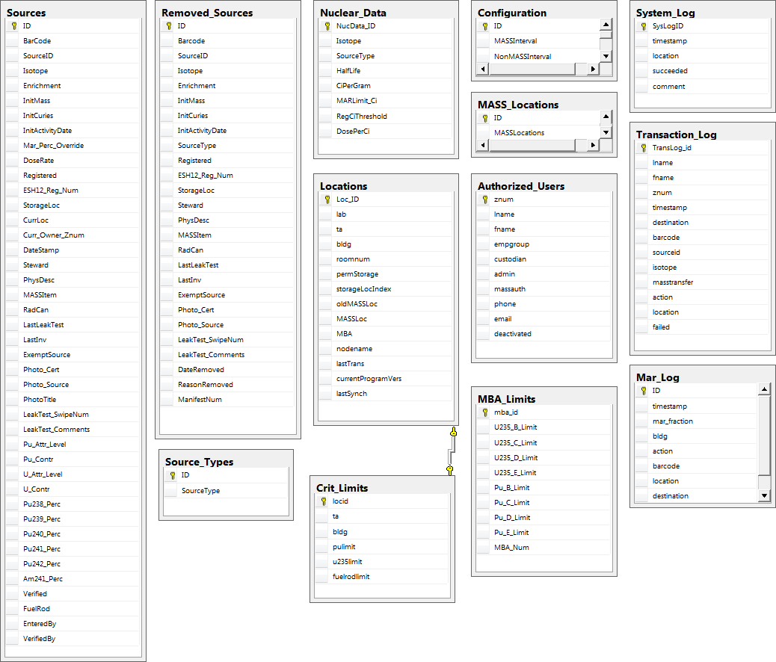
Figure 5 Database Tables, Relationships and Fields

Data Design
The data design is the database itself. See Figure 5 (above) and the detailed description of each database table in appendix A (below). Sources are described by several attributes. All data necessary for Source Tracker operations are contained in the database with the exception of the database connection string and the workstation location (stored locally on workstations).

Data Objects and Resultant Data Structures
At run time, Source Tracker builds internal C # class representations of the database tables into the immediate memory space of the application, using database support API components from Microsoft, and specialized structures for the type of data represented by the database tables. For example, a list of User objects is constructed from the Authorized Users table entry, which can be further filtered to only contain Custodians or Administrators. The software then uses this in-memory copy of the database state to respond to user actions. Data structures are populated in response to queries and commands from the user and are accessed in real-time.

File and Database Structures

Files to be Read
These configuration files are read by Source Tracker:
- SourceTracker.exe.config – Contains database connection and location information necessary to start the program.

Files to be Written
These data files are written by Source Tracker:
- Databases: The central database, using SQL transactions.
- Text files: Log files are only written to the local disk in cases of network/database failures. Otherwise, system and transaction logs are written to the central database or emailed to users upon request.

Modular Design

.NET Assemblies/Classes
SourceTracker.exe is the single main application program, written in C#. The application uses the window and messaging technology as the basis for interaction with the user and input devices. The modular decomposition falls into the following groups:
- DB -- general database access and control,
- UI -- Source Tracker user interface and presentation, including dialogs, tables, and related user presentation items, and
- DataStructures – The classes used to store information from database in local memory for manipulation
- Calculations -- The module used to make MAR, Criticality and Physical Security calculations.
- Utilities and Common – Classes used for miscellaneous program functions, such as shared configuration classes and extended forms and controls.

Figure 6 Source Tracker Class Diagram

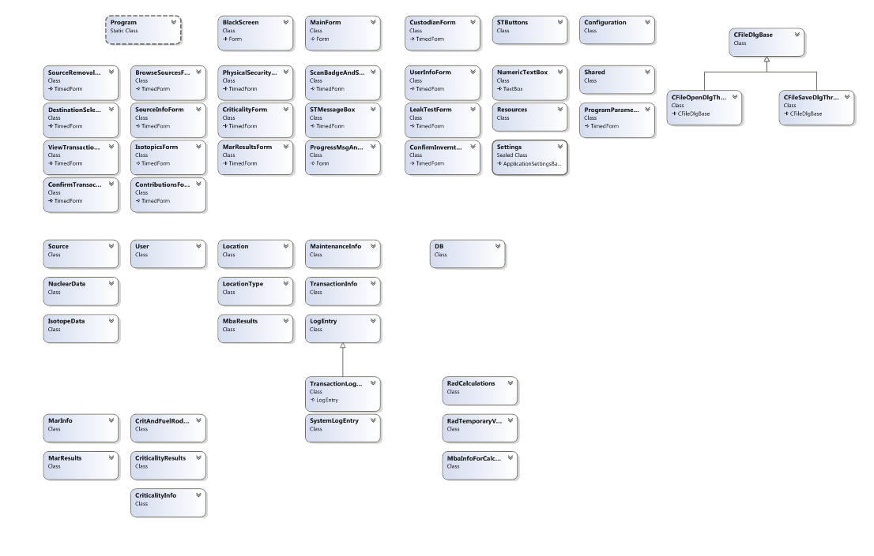

Processing Narrative
The Source Tracker software starts automatically when a client system is booted by configuring the Windows Task Scheduler. In the event that the software fails or the machine reboots, the scheduler is set to restart the application at short intervals to assure that the application is always running. The software takes control of the entire touch screen display, hiding the Windows desktop from users. Custodians and Administrators can exit the application by using a function within the Custodian Form.
The Source Tracker application continuously waits for input events from the touch screen and bar code reader. Based on the contextual state of the application, the software responds to user interaction by performing the context dependent touch screen display steps and database queries.

See the Source Tracker User’s Manual (NEN1-ST-UM).

Perhaps the most notable feature of Source Tracker is the rule-based transaction processing. Internal rules and conditions apply to operations that impact a source and any safety and hazard calculations. For example, an attempt to move a source to a new location invokes internal checks comparing source attributes such as isotopics, current location, and proposed new location status, against specific hazard and safety limits. These rules for comparison rules are encoded in the software application itself, the data driving the rules is present in both the application and the external database.

Data Structures
The runtime data structures generally reflect individual tables in the database. See Figure 5 and Appendix A for detailed data structure information.

Detailed Design
This section presents the detailed design for the Source Tracker software structure and processing algorithms satisfying the software requirements in Source Tracker Software Requirements Specification (NEN1-ST-SRS). Algorithms are described using pseudo-code with sequential, branch and loop statements, and boolean operators. Software structure supporting the algorithm is diagrammed for clarity. For each primary Software Requirement (SR), the related SR section is referenced on the right-hand side of the algorithm statements.

SR 1 – Verify MAR, Physical Security, Fuel Rod and Criticality Limits

Sources Table;
Nuclear Data Table;
Locations Table
Before & After Values;
OK-or-not message
Source Tracker EXE
Main
Database
User

For each building/MBA
For each Source
If not ANSI certified container OR if checked-out RadCan, Then [SR 1.2]
If Source has a MAR Percentage Override value
Then add it to CAT3 Total Percentage
Else calculate and add CAT3 Contribution Value to the CAT3 Total Percentage
Add Source CAT IV Contribution Value to the CAT IV Total
If source contributes to criticality
Calculate criticality values and add to total
If source is a fuel rod and building has fuel rod limits
Add fuel rod count to total
Show User Before Transfer and After Transfer Values [SR 1.1]
Compare Totals to Limits
If Exceeds Limits [SR 1.3 & 1.4]
Then display “Not OK to Transfer” message
Else display “OK to Transfer” message

When system starts up [SR 1.5]
Tally MAR, Physical Security, Criticality, and Fuel Rod values
Display that MAR, Physical Security and criticality values are being tallied

SR 2 – Transferring Accountable MASS or RSSDMS Sources

Reminder message
MASS Custodian
MASS-authorized User Z#
Email
MASS-authorized User
Main
Database
New Location
User
Source Tracker EXE

Locations Table;
Sources Table;
Authorized Users Table;

Sources Table
Transaction Log Table

If Source to transfer is a MASS or RSSDMS Source, Then
User selects new MASS location (to transfer to) for MASS items
OR selects any location for RSSDMS
If transfer is to another MBA, Then
Get and verify MASS-authorized user Z# [SR 2.2]
Remind User to notify MASS Custodian [SR 2.2]
Email MASS Custodian about the transfer
Else if transfer is across a MASS boundary (not to another MBA)
Remind User to notify MASS Custodian [SR 2.3]
Email MASS Custodian about the transfer [SR 2.3]
Else (within MBA and MASS area)
Email MASS Custodian about the transfer [SR 2.1]

SR 3 – Remove Source From Home Repository

User Z#;
Source (to remove);
New Location;
Continue option
Sources Table;
Authorized Users Table;
Locations Table
Error messages;
Source description & transfer details
Source Tracker EXE
Main
Database
User

Sources Table
Transaction Log Table

Get & verify User Z#; Get Source (to remove) from User [SR 3.1]
If Source Location is NOT = its Home Repository, Then [SR 3.2]
Display warning message [SR 3.2]
Verify Leak Testing [SR 3.7]
If Transferring a MASS or RSSDMS Source, Then
(do extra stuff, see 4.2) [SR 2]
Get New Location from User
Verify MAR, Physical Security, Fuel Rods and Criticality Limits [SR 1]
Display Source description and transfer details [SR 3.3]
If (exceeds MAR, Physical Security, Fuel Rod or Criticality Limits
Do not allow transaction [SR 1]
Else
Ask User to Complete, Cancel, or Complete-&-Do-More-Transfers? [SR 3.4]
If Complete OR Complete-&-Do-More-Transfers, Then
Update Source location & owner [SR 3.5]
If Complete-&-Do-More-Transfers
Then continue doing more transfers [SR 3.4]
Else (Cancel, so no Database update) [SR 3.6]

SR 4 – Return Source to Home Repository

Source Tracker EXE
Source (to return)
User
Main
Database
Sources Table;
Locations Table
Error message;
Home Repository Location

Sources Table
Transaction Log Table

Get Source (to return) from User [SR 4.1]
If source is shown as checked out [SR 4.2]
If Source Location NOT = its Home Repository, Then [SR 4.2]
Display error message & return to main screen [SR 4.3]
Else
Verify MAR, Physical Security, Fuel Rod and Criticality Limits [SR 1]
If (exceeds MAR, Physical Security, Fuel Rod or Criticality Limits
Do not allow transaction [SR 1]
Else
Update Source Location to its Home Repository Location [SR 4.4]
Display completion message

SR 5 – Re-Assign Source’s Current Location and/or Owner

User Z#;
Source (to re-assign);
New Location;
Continue option
Sources Table;
Authorized Users Table
Main
Database
Source Tracker EXE
User
Sources Table
Source description & transfer details

Get & verify User Z#; Get Source (to re-assign) from User [SR 5.1]
If Transferring a MASS Source or RSSDMS
Then (do extra stuff) [SR 2]
Get New Location from User [SR 5.2]
Verify MAR, Physical Security, Fuel Rods and Criticality Limits [SR 1]
Display Source description and transfer details [SR 5.3]
If (exceeds MAR, Physical Security, Fuel Rod or Criticality Limits
Do not allow transaction [SR 1]
Else
Ask User to Complete, Cancel, or Complete-&-Do-More-Transfers? [SR 5.4]
If Complete OR Complete-&-Do-More-Transfers, Then
Update Source location & owner [SR 5.5]
If Complete-&-Do-More-Transfers
Then continue doing more transfers [SR 5.4]
Else (Cancel, so no Database update) [SR 5.6]

SR 6 – Transaction Log

Main
Database
Source Tracker EXE
Notification message
Transaction Log Table
Custodian

Source Tracker EXE
Transaction Log Table
Report Request

Main
Database
Custodian

For every transaction performed by a User or a Custodian
Add transaction information into the Transaction Log Table [SR 6.1]

Custodian requests transaction log [SR 6.2]
Logs are retrieved from DB for dates requested [SR 6.2]
If Custodian requests email
Report is emailed to Custodian [SR 6.2]

SR 7 – Browse Sources
Main
Database
User Z#;
Sort option choice;
Browse search choices

Source Tracker EXE
User
Sources Table;
Authorized Users Table
Source information;
Source details;
Source picture

Get & verify User Z# [SR 7.1]
Get User Sort option choice [SR 7.3]
Get User Browse search choices [SR 7.4 (7.4.1-7.4.5)]
Display Source information (bar code number, source ID, [SR 7.2]
isotope, initial mass, initial and current activities, current owner,
locations, dose rate, MAR, and criticality for each source selected, [SR 7.4, 7.4.5]
sorted by user sort option choice) [SR 7.3]
If User chooses to display source details about a source, [SR 7.5, 7.6]
Then display source details
If User wants to see the sources they currently have checked out, [SR 7.7]
User selects his name as User Z# for source filtering [SR 7.4]
Set current owner to User Z# (selects sources to display)
Display Source information (normal browse display)

SR 8 – Display Category 3 MAR Status For Each of the Radiation Facilities
Sources Table;
Authorized Users Table;
Locations Table
Main
Database
Source Tracker EXE
User
User Z#

MAR Percentages per Building

Get & Verify User Z# [SR 8.1]
For each building [SR 8.2]
For each Source
If not ANSI certified container, Then
If Source is a checked-out radiation Canister (RAD Can)
Then Add it to the appropriate CAT3 Building RAD Can Percentage
(If Source has a MAR Percentage Override value then use the MAR
Percentage Override value, else use the CAT3 Contribution Value)
Else add it to the appropriate CAT3 Building Base Percentage
(If Source has a MAR Percentage Override value, then use the MAR
Percentage Override value, else use the CAT3 Contribution Value)
Display the CAT3 Percentages per building (display the RAD Can Percentage,
Base Percentage, and the total of those values), highlighting any that are
over the limit

SR 9 – Display Category IV Physical Security Status for Each of the MBAs
Sources Table;
Authorized Users Table;
CAT IV Areas Table

Main
Database
Source Tracker EXE
User
User Z#

CAT IV Percentages per MBA

Get & verify User Z# [SR 9.1]
For each MBA [SR 9.2]
For each Source
Add the CAT IV PU Contribution value to the appropriate MBA and attractiveness
level (B, C, D, & E) plutonium sub-total
Add the CAT IV U Contribution value to the appropriate MBA and attractiveness
level (B, C, D, & E) uranium sub-total
Display the CAT IV sub-totals per MBA Area (display by attractiveness levels
and isotope type), highlighting any that are over limits

SR 10 – Display Criticality and Fuel Rod Status for each of the Radiation Facilities

Sources Table;
Authorized Users Table;
Crit_Limits Table

Main
Database
Source Tracker EXE
User
User Z#

Criticality values and fuel rod counts per building

Get & verify User Z# [SR 9.1]
For each source
Calculate criticality contributions, if any
Sum criticality values by building
Calculate fuel rod count, if any
Sum fuel rod count by building
Get criticality and fuel rod limits from DB
For each building [SR 9.2]
Populate the table with the building, criticality values, and fuel rod count
Compare with limits and highlight any that exceed limits

SR 11 -- Sample Source Transaction
Sources Table;
Authorized Users Table;
Nuclear Data Table
Locations Table
User Z#

Main
Database
Source Tracker EXE
User

Get & verify User Z#; Get Source from User [SR 11.1]
Summary of MAR, Physical Security, Fuel Rod Limits for test transaction
Perform Remove, Reassign, Return or Permanently Transfer up to
Results for MAR, physical security, criticality and fuel rod [SR 11.1]
User may only click Cancel, which prevents any database update

SR 12 -- Confirm Inventory

Custodian Z#;
Source display choice;
Scanned sources
Sources Table;
Authorized Users Table
Main
Database
Source Tracker EXE
Custodian
Summary List Email

Get & verify Custodian Z# [SR 12.1]
Loop until Custodian selects Cancel or Finished
Get Custodian source display choice (all sources, [SR 12.2]
only checked-out sources, or only checked-in sources)
Display list of sources matching the display choice [SR 12.2]
Display running totals (to be confirmed, confirmed, and unexpected) [SR 12.3]
Get scanned source barcode (to confirm inventory) from Custodian [SR 12.4]
Update the source’s last inventory date (to the current date) [SR 12.4]
Verify Leak Testing [SR 12.5 (see SR 17)]
Remove the scanned source from the source list displayed
If source is unexpected, Then
Display expected location [SR 12.6]
Increment (& display) unexpected running total [SR 12.3]
Else
Increment (& display) confirmed running total [SR 12.3]
Decrement (& display) to be confirmed running total [SR 12.3]
End Loop
If sources still in source list (still need to be confirmed), Then
Display warning message & [SR 12.7]
a summarized list of confirmed sources [SR 12.8]
Update System Log with totals
Send summarized list of confirmed sources via email to Custodian [SR 12.8]
(including unexpected sources)

SR 13 – Transfer a Source Permanently From One Location to Another

Sources Table;
Authorized Users Table;
Locations Table;
Source description & transfer details;
Reminder message
Main
Database
Source Tracker EXE
Custodian
Custodian Z#;
Source (to transfer);
New Location;
Continue option

Sources Table
Transaction Log

Get & verify Custodian Z# [SR 13.1]
Get scanned source (to transfer) from Custodian [SR 13.2]
Get new permanent location (home repository) from Custodian [SR 13.4]
If a valid permanent location, Then [SR 13.4]
Verify MAR, Physical Security, criticality, and fuel rod Limits [SR 13.3 (see SR 1)]
Display Source description and transfer details [SR 13.5]
If within limits,
Ask Custodian to Complete or Cancel? [SR 13.6]
If Complete, Then
Update Source location [SR 13.7]
Else (Cancel, so no Database update) [SR 13.8]
If source is a MASS source, Then [SR 13.9 (see SR 2)]]
Display message that MASS system must be updated

SR 14 – Create a Summary csv File of Sources
Custodian
Custodian Z#

Email w/Summary File
Main
Database
Sources Table;
Authorized Users Table
Summary File

Source Tracker EXE

Get & verify Custodian Z# [SR 14.1]
Create Summary File (list of sources) containing all sources - [SR 14.2]
information for each source includes bar code number, source ID, [SR 7.2]
isotope, initial mass, initial and current activities, current owner,
locations, dose rate, MAR, and criticality
If User wants to filter the results, they can be filtered as for Browse Sources [See SR7]
Email Summary File to Custodian & display message that email was sent [SR 14.3/24.3]

SR 15 – Edit Program Parameters
Get and verify Get & verify Custodian Z# [SR 15.1]
Config File

Database Connection String
Workstation Location
Leak Test Parameters
Configuration Table
Custodian
Main
Database
Notification that Settings are changed
Source Tracker EXE
Custodian Z#

If (Custodian changes database)
Connect to requested database [SR 15.4]
If (Custodian changes location)
Change location in config file [SR 15.2]
If (Custodian changes leak test parameters)
Store in Configuration table in DB [SR 15.3]
To change main database connection
Modify connection string in .config file [SR 15.5]

SR 16 -- Record Leak Testing

Custodian Z#;
Source display choice;
Scanned sources
Sources Table;
Authorized Users Table
Source Tracker EXE
Main
Database

Custodian

Update Source Table with new Leak Test Date

Summary List Email

Get & verify Custodian Z# [SR 16.1]
Loop until Custodian selects Cancel or Finished
Get Custodian source display choice (all sources [SR 16.2]
only checked-out sources, or only checked-in sources)
Display list of sources matching the display choice [SR 16.2]
If (Custodian requests Source detail) [SR 16.2]
Show source detail [SR 16.2]
Display running totals (to be leak tested, leak tested, and unexpected) [SR 16.3]
Get scanned source barcode from Custodian [SR 16.4]
If Custodian also wants to confirm inventory, Then [SR 16.5]
Update the source’s last inventory date (to the current date)
Remove the scanned source from the source list if not unexpected
If source is unexpected, Then
Display expected location [SR 16.6]
Increment (& display) unexpected running total [SR 16.3]
Else
Increment (& display) leak tested running total [SR 16.3]
Decrement (& display) to be leak tested running total [SR 16.3]
End Loop
If sources still in source list (still need to be leak tested), Then
Display warning message & [SR 16.7]
a summarized list of leak tested sources [SR 16.8]
Update System Log with totals
Send summarized list of leak tested sources via email to Custodian [SR 16.8]
(including unexpected sources and all sources still needing
leak testing)

SR 17 – Verify Leak Testing

Sources Table
Warning message
User
Source Tracker EXE
Main
Database

Compare source’s time since last leak test to appropriate leak test
parameter days allowed
If Leak Testing is past due, Then
If extra days parameter (grace period) has already passed, Then
Don’t allow the transfer
Else (grace period has not passed) [SR 17.1]
Display the last leak test date
Display warning message
Allow the transfer
Email Custodian that a source has an expired leak test date
Else
Allow transaction

SR 18 – Automatic Database Backups
Tivoli Backup Manager
Daily [SR 18.1]
Central Database
Tivoli Storage
Backup central database to Tivoli Storage
If (Backup fails)
Send email [SR 18.2]

SR 19 -- Manually Input MAR (CAT 3) Contribution Value For a Source

Sources Table
Authorized_Users Table
MAR override value
Custodian
Source Tracker EXE

Main
Database

MAR override value to Sources Table
Warning message

Get & verify Custodian Z# [SR 19]
Select Add/Modify Source button and modify the MAR Percentage entry
If (new MAR value OK)
Store MAR override value in database [SR 19]

SR 20 – Time-out Timers

Custodian

Source Tracker EXE
Main menu

Main menu
User

Timer

If a User or a Custodian begins an operation that displays a screen other than [SR20]
the main menu and does not complete the operation or continue
interacting with the screen within a time limit, Then
Cancel the transaction
Display the previous (parent) screen

SR 21 – Add/Delete/Modify Source Information
Source Tracker EXE
User Z# scanned
Source barcode scanned
Main
Database
Authorized_Users Table
Sources Table
Custodian
Writes/Updates Sources Table
Email to Custodians
for verification
Get & verify Custodian Z# [SR 21.1]
Select Add/Modify Source from custodian menu
Get source barcode [SR 21.3]
Allow editing of source information [SR 21.3/21.4]
If user selects Save
If (Source exists in database)
Store source information [SR 21.2]
Else (Source is new)
Store source information and mark ‘unverified’ [SR 24.4]
Email all custodians to notify of new source verification
Else if user selects Cancel
Return to custodian form
Else if user selects Delete
If source has been verified [SR 1]
Write (some) source information to the Removed Sources table
Remove source from the Sources table

SR 22 – Add/ Modify User Information
Get & verify Custodian Z# [SR 22.1]
New user warning
Writes/Updates Authorized_Users Table
User Z# scanned
Custodian
Source Tracker EXE
Authorized_Users Table
Main
Database
Select Add/Modify User from custodian menu
Allow editing of user information [SR 22.3]
If user selects Save/Update
If (User exists in database)
Store user information [SR 22.2]
Else (Source is new)
Store user information [SR 22.2]
Display warning to check user training
Else if user selects Cancel
If data has been entered then
Ask user if they want to lose the changes
If user answers Yes
Return to custodian form
Else
Return to user information
Else
Return to custodian form

SR 23 – Procedure in Case of Network Outage
User requests action needing DB
User Z# scanned or
source barcode scanned
Main
Database
Source Tracker EXE
User
DB fail warning
Source Tracker unable to connect to central DB [SR 23.1]
Show warning to user [SR 23.1]
Return to Main Screen [SR 23.1]
Until (Database available) [SR 23.1]
Disallow transactions

SR 24 – Email Notification Requirements
Each night [SR 24.6]
Main
Database
Email results to custodians
Query sources in non-permanent Storage Location
Daily – Stored Procedure
Run stored procedure to query sources not in permanent storage
Email results [SR 24.6]
User requests transaction
Main
Database
Source Tracker EXE
User Z# scanned or
source barcode scanned
Warning -- Unauthorized
Unauthorized User
Email notice to custodians
Authorized_Users Table
If (User is not an authorized user) [SR 24.5]
Show warning
Disallow transaction
Send email to custodians
At startup
Main
Database
Source Tracker EXE
Email notice to custodians
Sources Table
Locations Table
At startup
Do MAR, Physical Security, Fuel Rod and Criticality calculations
Do calculations
If (MAR > 80%) [SR 24.2]
Email warning to Custodians
If physical security, criticality, or fuel rod limits are exceeded
Email warning to custodians
User scans MASS source
Main
Database
Source Tracker EXE
MASS/RSSDMS source barcode scanned
Warning – MASS source
Email notice to custodians
Sources Table
User
Warn MASS source requirements [SR 24.1]
Email warning to Custodians
User scans RSSDMS source
Email warning to custodians
*note: Requirements for 24.3 are shown in Section 4.14 and requirements for 24.4 are shown in Section 4.21

SR 25 – System Security Requirements
User
Requests Shutdown
Custodian
Source Tracker EXE
Windows Scheduler
Verifies that Source Tracker Application is running. Restarts if needed.
At startup and indefinitely every 1 minute [SR 25.1]
Check that Source Tracker is running
If (Not running)
Start Source Tracker

Get & verify Custodian Z# [SR 25.2]
Shut down [SR 25.1]

Implementation Language
The SourceTracker.exe application is written in C # and compiled with the Microsoft Visual Studio C # VS2013.

Traceability
Requirements found in (NEN1-ST-SRS) as satisfied by the software design are shown in the design details section above. See also (NEN1-ST-RTM), the Requirements Traceability Matrix.

Appendix A: Database Table Description
Table Name | Column Name | Data Type | Length | Can be blank
Authorized_Users | znum | int | 4 | 0
 | lname | nvarchar | 100 | 1
 | fname | nvarchar | 100 | 1
 | empgroup | nvarchar | 100 | 1
 | custodian | bit | 1 | 0
 | admin | bit | 1 | 0
 | massauth | bit | 1 | 0
 | phone | nvarchar | 100 | 1
 | email | nvarchar | 100 | 1
 | deactivated | bit | 1 | 0
Configuration | ID | int | 4 | 0
 | MASSInterval | int | 4 | 1
 | NonMASSInterval | int | 4 | 1
 | GracePeriod | int | 4 | 1
Crit_Limits | locid | int | 4 | 0
 | ta | nvarchar | 100 | 0
 | bldg | nvarchar | 100 | 0
 | pulimit | float | 8 | 1
 | u235limit | float | 8 | 1
 | fuelrodlimit | int | 4 | 1
Locations | Loc_ID | int | 4 | 0
 | lab | nvarchar | 60 | 0
 | ta | nvarchar | 20 | 1
 | bldg | nvarchar | 20 | 1
 | roomnum | nvarchar | 20 | 1
 | permStorage | bit | 1 | 0
 | storageLocIndex | smallint | 2 | 1
 | oldMASSLoc | smallint | 2 | 1
Locations (cont.) | MASSLoc | nvarchar | 100 | 1
 | MBA | nvarchar | 100 | 1
 | nodename | nvarchar | 40 | 1
 | lastTrans | datetime | 8 | 1
 | currentProgramVers | nvarchar | 100 | 1
 | lastSynch | datetime | 8 | 1
Mar_Log | ID | int | 4 | 0
 | timestamp | datetime | 8 | 1
 | mar_fraction | float | 8 | 1
 | bldg | nvarchar | 510 | 1
 | action | nvarchar | 510 | 1
 | barcode | nvarchar | 510 | 1
 | location | nvarchar | 510 | 1
 | destination | nvarchar | 510 | 1
MASS_Locations | ID | int | 4 | 0
 | MASSLocations | nvarchar | 510 | 1
 | description | nvarchar | 510 | 1
MBA_Limits | mba_id | int | 4 | 0
 | U235_B_Limit | float | 8 | 1
 | U235_C_Limit | float | 8 | 1
 | U235_D_Limit | float | 8 | 1
 | U235_E_Limit | float | 8 | 1
 | Pu_B_Limit | float | 8 | 1
 | Pu_C_Limit | float | 8 | 1
 | Pu_D_Limit | float | 8 | 1
 | Pu_E_Limit | float | 8 | 1
 | MBA_Num | int | 4 | 1
Nuclear_Data | NucData_ID | int | 4 | 0
 | Isotope | nvarchar | 510 | 1
 | SourceType | nvarchar | 510 | 1
 | HalfLife | float | 8 | 1
Nuclear_Data (cont.) | CiPerGram | float | 8 | 1
 | MARLimit_Ci | float | 8 | 1
 | RegCiThreshold | float | 8 | 1
 | DosePerCi | float | 8 | 1
Removed_Sources | ID | int | 4 | 0
 | Barcode | nvarchar | 20 | 0
 | SourceID | nvarchar | 40 | 1
 | Isotope | nvarchar | 100 | 1
 | Enrichment | real | 4 | 1
 | InitMass | real | 4 | 1
 | InitCuries | real | 4 | 1
 | InitActivityDate | datetime | 8 | 1
 | SourceType | nvarchar | 100 | 1
 | Registered | bit | 1 | 0
 | ESH12_Reg_Num | nvarchar | 100 | 1
 | StorageLoc | nvarchar | 60 | 1
 | Steward | nvarchar | 100 | 1
 | PhysDesc | nvarchar | 400 | 1
 | MASSItem | bit | 1 | 0
 | RadCan | bit | 1 | 0
 | LastLeakTest | datetime | 8 | 1
 | LastInv | datetime | 8 | 1
 | ExemptSource | bit | 1 | 0
 | Photo_Cert | varbinary | -1 | 1
 | Photo_Source | varbinary | -1 | 1
 | LeakTest_SwipeNum | int | 4 | 1
 | LeakTest_Comments | nvarchar | 100 | 1
 | DateRemoved | datetime | 8 | 1
 | ReasonRemoved | nvarchar | 400 | 1
 | ManifestNum | nvarchar | 100 | 1

Source_Types | ID | int | 4 | 0
 | SourceType | nvarchar | 100 | 1
Sources | ID | int | 4 | 0
 | BarCode | nvarchar | 20 | 0
 | SourceID | nvarchar | 40 | 1
 | Isotope | nvarchar | 100 | 1
 | Enrichment | real | 4 | 1
 | InitMass | real | 4 | 1
 | InitCuries | real | 4 | 1
 | InitActivityDate | datetime | 8 | 1
 | Mar_Perc_Override | real | 4 | 1
 | DoseRate | real | 4 | 1
 | Registered | int | 4 | 1
 | ESH12_Reg_Num | nvarchar | 100 | 1
 | StorageLoc | nvarchar | 60 | 1
 | CurrLoc | nvarchar | 60 | 1
 | Curr_Owner_Znum | int | 4 | 1
 | DateStamp | datetime | 8 | 1
 | Steward | nvarchar | 100 | 1
 | PhysDesc | nvarchar | 400 | 1
 | MASSItem | bit | 1 | 0
 | RadCan | bit | 1 | 0
 | LastLeakTest | datetime | 8 | 1
 | LastInv | datetime | 8 | 1
 | ExemptSource | bit | 1 | 0
 | Photo_Cert | varbinary | -1 | 1
 | Photo_Source | varbinary | -1 | 1
 | PhotoTitle | nvarchar | 100 | 1
 | LeakTest_SwipeNum | int | 4 | 1
 | LeakTest_Comments | nvarchar | 100 | 1
 | Pu_Attr_Level | nvarchar | 100 | 1
Sources (cont.) | Pu_Contr | float | 8 | 1
 | U_Attr_Level | nvarchar | 100 | 1
 | U_Contr | float | 8 | 1
 | Pu238_Perc | real | 4 | 1
 | Pu239_Perc | real | 4 | 1
 | Pu240_Perc | real | 4 | 1
 | Pu241_Perc | real | 4 | 1
 | Pu242_Perc | real | 4 | 1
 | Am241_Perc | real | 4 | 1
 | Verified | bit | 1 | 0
 | FuelRod | int | 4 | 1
 | EnteredBy | int | 4 | 1
 | VerifiedBy | int | 4 | 1
System_Log | SysLogID | int | 4 | 0
 | timestamp | datetime | 8 | 1
 | location | nvarchar | 100 | 1
 | succeeded | bit | 1 | 0
 | comment | nvarchar | 500 | 1
Transaction_Log | TransLog_id | int | 4 | 0
 | lname | nvarchar | 30 | 1
 | fname | nvarchar | 30 | 1
 | znum | int | 4 | 1
 | timestamp | datetime | 8 | 1
 | destination | nvarchar | 100 | 1
 | barcode | nvarchar | 20 | 1
 | sourceid | nvarchar | 40 | 1
 | isotope | nvarchar | 50 | 1
 | masstransfer | bit | 1 | 0
 | action | nvarchar | 100 | 1
 | location | nvarchar | 60 | 1
 | failed | bit | 1 | 0

